H26R
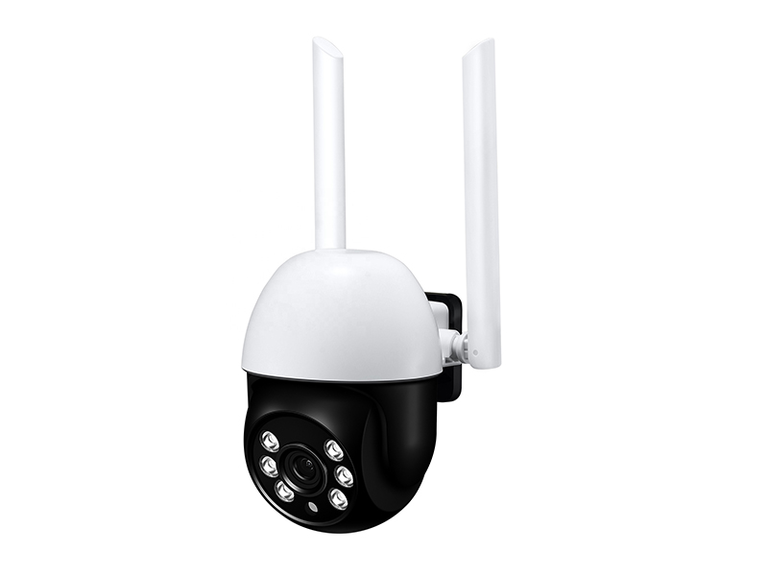
Smart and exquisite design, good quality;
High-performance main control chip, support humanoid detection and humanoid tracking;
2.0 megapixel HD image sensor, maximum resolution 1920x1080;
Support WiFi, Support AP hotspot;
Support up to 128G TF Card Storage;
6pcs array infrared&floo light LEDs, irradiation distance 20m, support color night vision;
Support two way audio(built-in MIC and Speaker);
Pan tilt rotation, horizontal:320°&vertical:90°;
3.6mm ixed focus high-definition lens
outdoor use, waterproof IP66;
Support P2P, view & anywhere & anytime;
Elegant outline and easy installation;
Provide android & ios Camhipro APP and professional CMS PC client software;
Model |  | H26R
Video | Sensor | 2.0 megapixel 1/3" GC4653 CMOS
Video | Video resolution | Main stream: 1920x1080@20fps  Sub stream: 640x352@25fps
Video | Video compression | H.264/H.265
Video | Lens | 3.6mm lens
Video | View angle | 82.5°
Video | Night vision | 6pcs array infrared&white light LEDs, irradiation distance 20m,support color night vision
Audio | Audio compression | G.726/G.711
Audio | Audio code rate | 8Kbps, 16bit
Audio | Audio input/output | Built-in MIC and speakers, support two way audio
Alarm | Motion detection | Can set 4 independent detection areas, can set the sensitivity of 1-100
Alarm | Humanoid detection | Support, can be used in conjunction with motion detection to make the alarm more accurate
Alarm | Alarm linkage | Alarm mobile phone message push,  Alarm recording or capture to Micro SD card,  Alarm trigger sound alarm,  Alarm capture sent to Email,  Alarm recording or capture saved to FTP
Alarm | Alarm time | All day or manually customize alarm time period
Interface | Power | 5V USB power interface
Interface | Reset button | Support, press for 5 seconds to reset the camera
Interface | Micro SD card | Support up to 128G micro SD card
Interface | Wireless | IEEE 802.11 b/g/n
Interface | Onvif protocol | Support ONVIF 2.4(backward compatible)
PTZ | Rotation angle | Horizon: 320°, Vertical: 90°
PTZ | Horizontal speed | 30°/S
PTZ | Vertical speed | 35°/S
PTZ | Preset | Support preset position, support humanoid tracking
General specification | Power consumption | Day: 2W, Night: 5W
General specification | Operating environment | Environment -20℃~+60℃(-4℉~+140℉),  Humidity 10%~90%, non-condensing
General specification | Shell material | ABS plastic
General specification | Waterproof level | IP65
General specification | Product size | 90mm×105mm×190mm(L×W×H)
General specification | Product weight | 0.35kg
General specification | Package size | 100mmx100mmx165mm(L×W×H)
General specification | Package weight | 0.4kg

