Metal Vandalproof /Waterproof HD IP IR Dome Camera (30 IR LED)
Model No.: XIP317HW3E

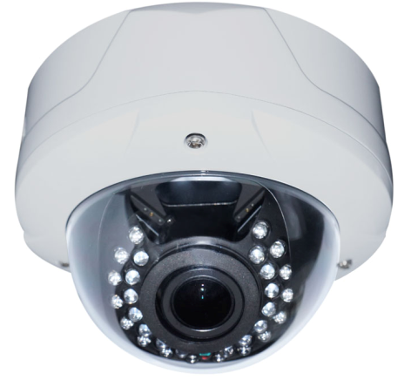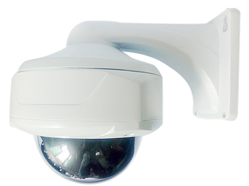
Main feature:

- Professional design for HD network camera, small, beautiful and delicate, best for home security.
- Material: aluminum alloy, innovative patented heat dissipation structure, make HD camera can works well under high temperature.
- 3.0 megapixel, Sony progressive scan
- Advanced digital signal processing technology, high brightness imported SMT IR source, show the best HD video effects in both day and night environment.
- 3.0 Megapixel HD CS lens+ IR-CUT auto switch in day and night, 3.6mm,6mm fixed focus lens optional
- 30 IR LED, effective night vision distance is 25~35m, excellent performance in dark environment.
- Support 3D DNR, auto white balance, auto electronic shutter, auto electronic gain, real color reproduction, high resolution image.
- ONVIF protocol, can provide the SDK.

Optional back-end products for the system:

IE browse software, P2P HD remote monitoring management software (one key realize remote control without complicated settings), Embedded HD NVR, NVR control keyboard, CMS HD network surveillance platform management software, High-definition surveillance analysis software.

Technical parameters:
Model: |  | XIP317HW3E
Camera | Imaging sensor: | 3.0MP,H.265+,  MStar325+IMX317 ,1/2.9″ CMOS, Starlight
Camera | Scanning mode: | Progressive scanning
Camera | Illumination: | color 0.01Lux@F1.2,black/white:0.005Lux@F1.2, IR on 0 lux
Camera | Lens: | Standard with 3 megapixel 3.6mm,6mm fixed focus CS lens
Camera | Day and night switch: | IR-CUT dual optical filters auto switch in day and night
Camera | DNR: | 3D-DNR
Camera | IR source: | 30 pcs IR Led
Camera | Effective night vision distance: | 25~35 meters (measured value without light condition)
Camera | P2P | YES
Camera | WDR | 128db
Camera | S/N Ratio | 50db
Camera | Privacy mask | 1
Camera | shutter speed | 1/(10-10000)s
Camera | FTP | YES
Standard compression | Image compression: | H.264
Standard compression | Video compression: | H.265+/H.265/H.264, support dual-stream, AVI format; support stream 32Kbps ~ 3.5Mpbs adjustable;support CBR/VBR
Image | Max image size: | 3MP
Image | Frame rate: | 3MP/2048*1536@25fps、1080P@30fps
Function | Interface protocol: | HTTP/RTSP/FTP/PPPOE/DHCP/DDNS/NTP/ONVIF2.6/,Hikvision private protocol
Function | Intelligent alarm: | Motion detection, shadow alarm, network cable break, IP address conflict
Function | POE | YES (optional),IEEE802.3at/af Standard  PoE/IN:37-57V(15.4W), DC/OUT:12V/1A(12.95W)
Function | Lightning Protection | Power, network, POE comprehensive lightning protection, in line with national standards GB/T17626.5, the international standard IEC61000-4-5.
Function | features | Support WEB configure, support for OSD, support video transmission,support mobile surveillance, support for mobile detection alarm center after the screen pop-up reminders and linkage; supports JPEG capture; provide perfect the SDK development package
Basic parameter | Power input: | DC 12V±10%
Basic parameter | Power consumption: | 1W (IR off) / 9.5W (IR on) | 1.1W / 9.6W (IR on)
Basic parameter | Work environment: | -40℃ ~ 85℃, humidity is less than 95% (no condensation)

